EICC Email Signature Instructions

# Use the following template to create your email signature in Outlook:

Your Name  
Position or Title

Campus Name

Street Address, City

563-555-5555 | [eicc.edu](https://www.eicc.edu/)

[Eastern Iowa Community Colleges is an Equal Opportunity Educator and Employer.](https://eicc.edu/eeo)

# Instructions:

**Step 1:** Highlight all text between the two dotted lines above, starting with “Your Name…” and ending with “…and Employer.”

**Step 2:** Right-click the highlighted text and select “**Copy**” (or press **Ctrl + C** on your keyboard).

**Step 3:** Open Outlook and click the “**New Mail**” button.

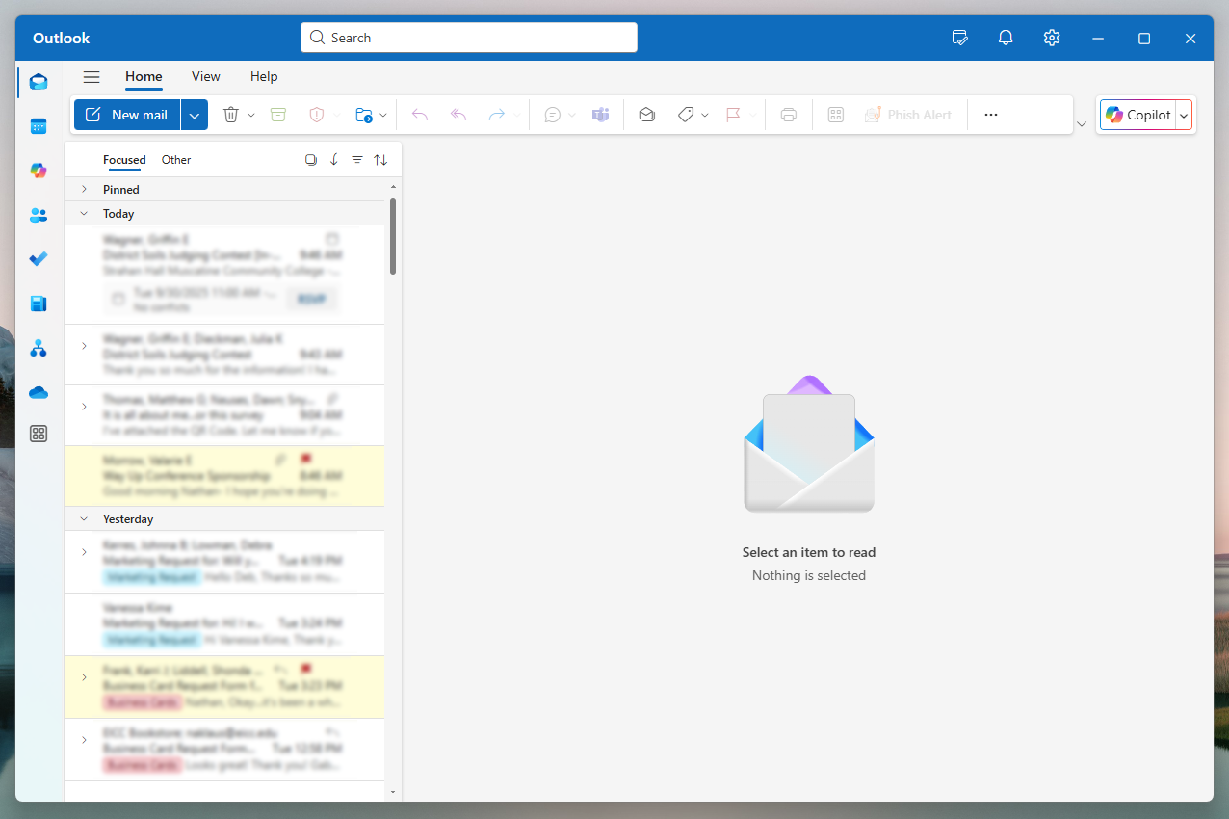

**Step 4:** Within the menu bar, select “**Insert**.”

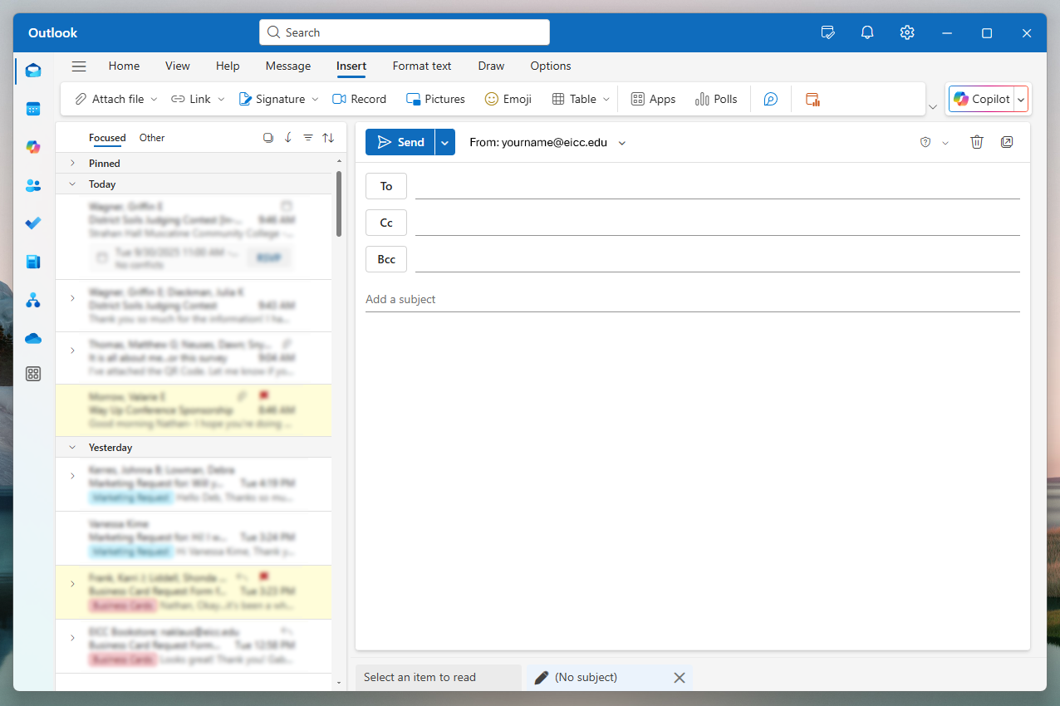

**Step 5:** Select the “**Signature**” button in the submenu bar, and then click “**Signatures…**”.

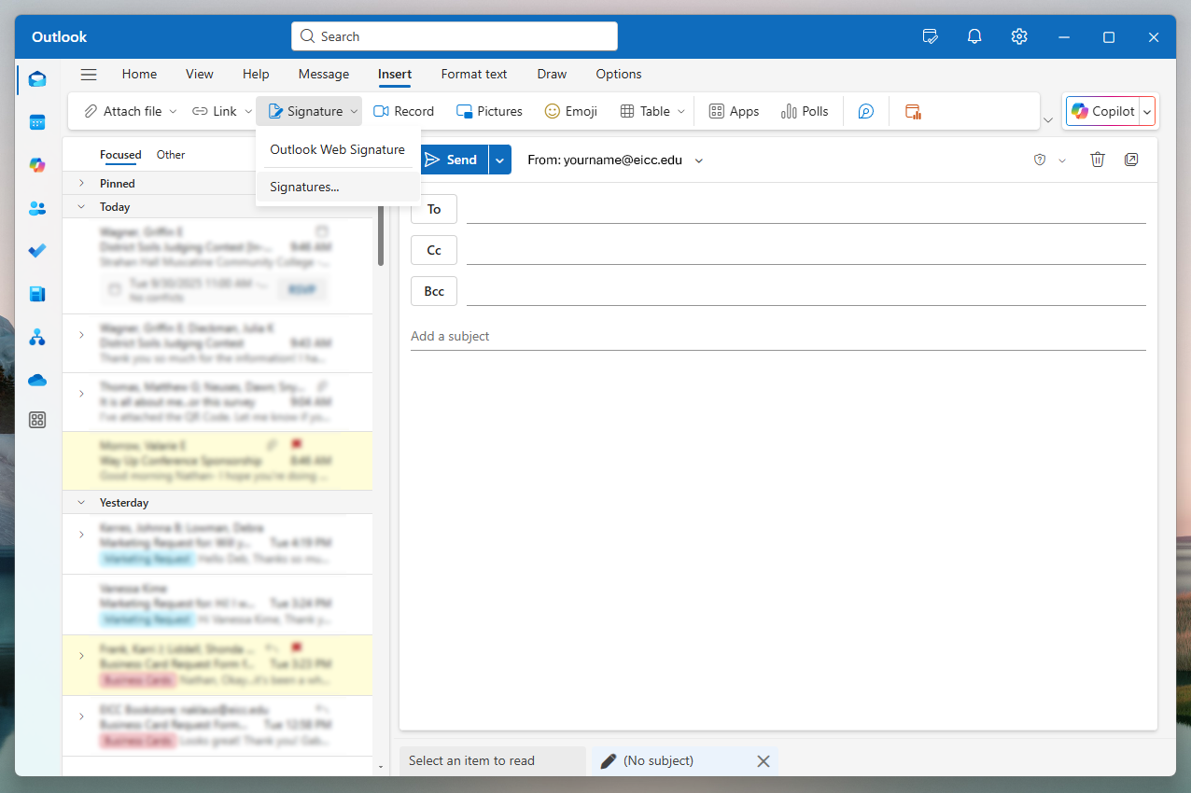

**Step 6:** In the resulting window, select **“+ New signature**” and enter a name for your new signature.

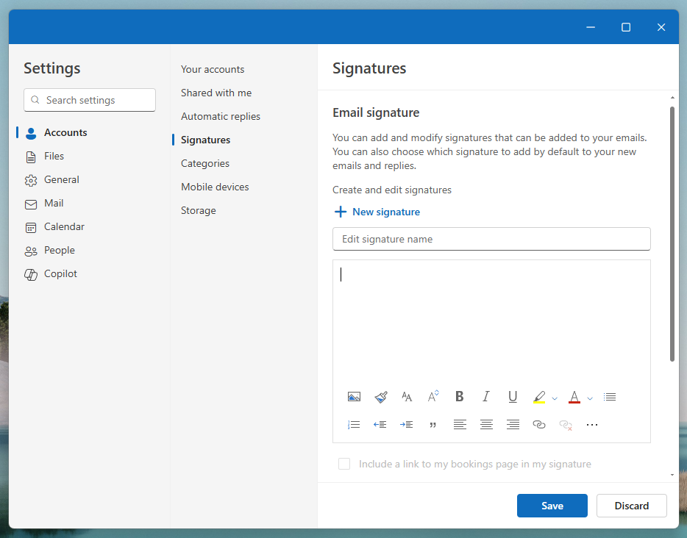

**Step 7:** Place your cursor in the blank editor window below, and then press **Ctrl + V** on your keyboard. This will paste the template into place.

*Note: The “Ctrl + V” keyboard shortcut ensures the copied text will appear properly when pasted into Outlook. Right-clicking and selecting “Paste” will cause unnecessary line spacing, but Ctrl + V does not.*

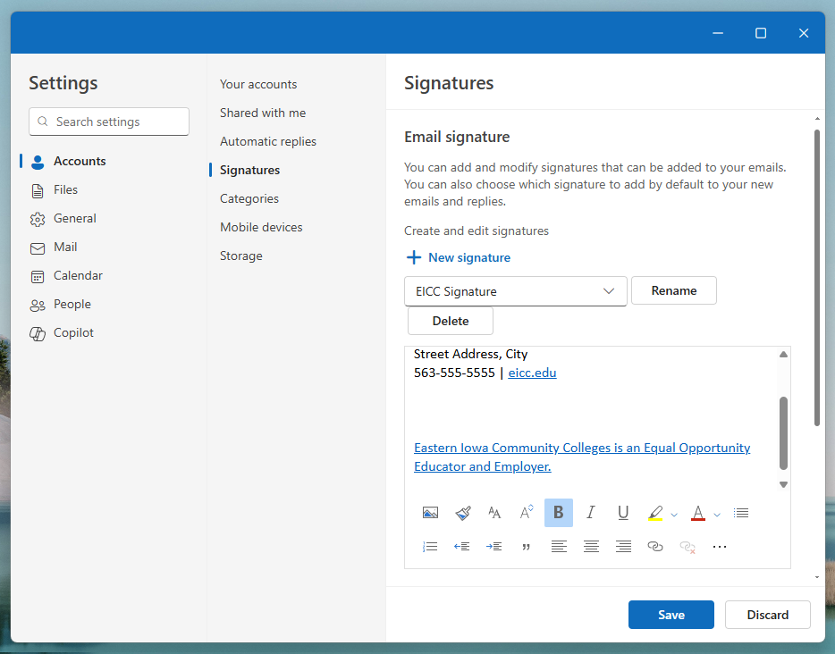

**Step 8:** Without changing its size, right-click the following image and select “**Copy**” (**Ctrl + C**):



**Step 9:** Return to the signature template in your Outlook settings. Placing your cursor between the contact information and EEO, right-click and select “**Paste**” (**Ctrl + V**) to paste the logo in place.

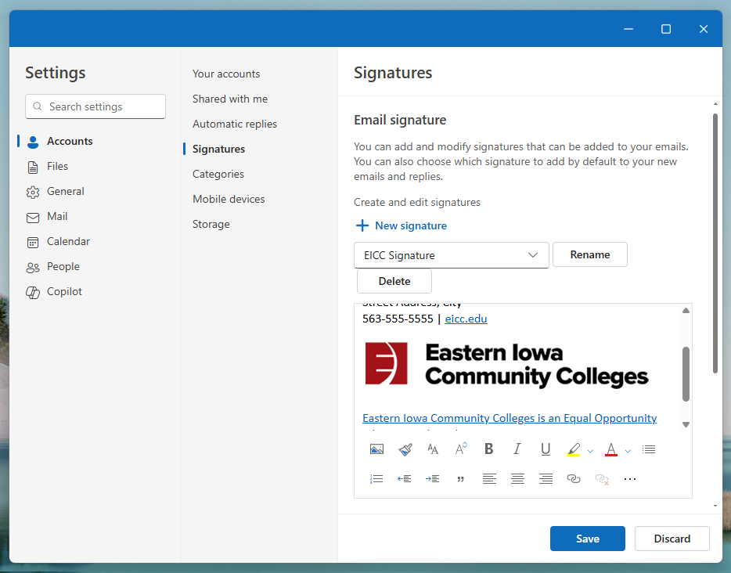

**Step 10:** Customize your contact information as desired. You may embolden your name/title or customize the URL to suit a program-specific web shortcut or online resource (e.g. [eicc.edu/programs](https://eicc.edu/programs), [eicc.edu/services](https://eicc.edu/services), etc.). When finished, click “**Ok**,” followed by the blue “**Save**” button to save your new signature.

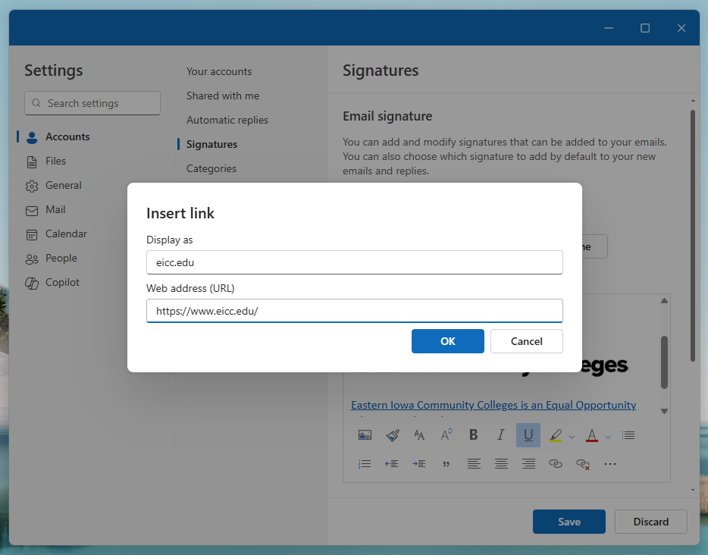

**Step 11:** Your signature is ready! You may now add it to your blank email by navigating to “**Insert**,” then “**Signature**” and clicking your new signature name. It will also be present on all new email drafts until you create an alternate, or disable signatures altogether, by selecting the “**Signatures…**” option (under **Insert** > **Signatures**). You may also apply any edits or create alternate signatures within this window using your new signature as a template.

